Lab Sheet: Chi-Square (χ2) Analysis with R
Objective: To perform Chi-Square tests for Goodness-of-Fit (one-way tables) and Independence (two-way tables) using R.

1. One-Way Contingency Table: Equal Probabilities (5 Minutes)
This test determines if observed frequencies differ significantly from a distribution where all categories have an equal chance of occurring.
- Data Input: Use the c() function to enter observed frequencies.
- R Function: Use chisq.test(data, correct=FALSE).

Exercise Snippet (Industrial Accident Study):
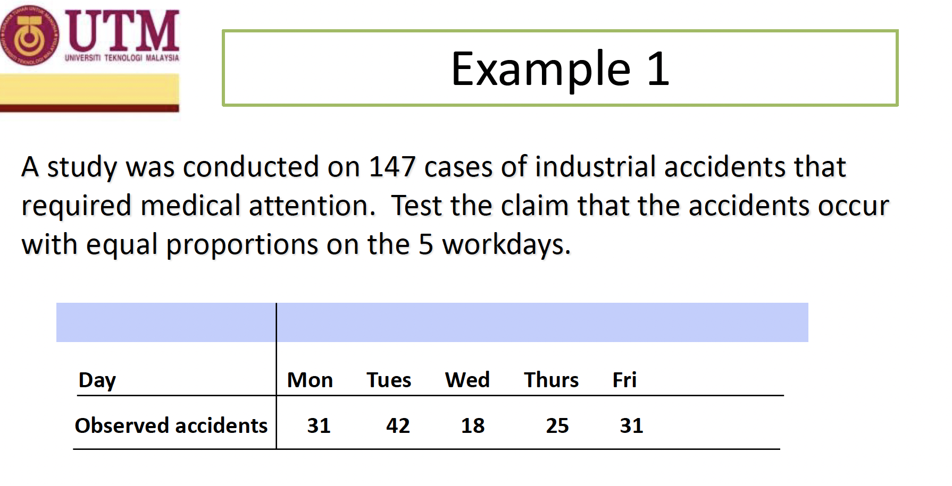
H₀: P₁=P₂=P₃=P₄=P₅
H₁: At least 1 of the 5 proportions is different from others

#Observed accidents from Monday to Friday
noAcc <- c(31, 42, 18, 25, 31)
expprob <- sum(noAcc)/5
expAcc <- c(expprob, expprob,
expprob, expprob, expprob)

#Perform Chi-Square test for equal proportions
output <- chisq.test(noAcc, correct=FALSE)
output

#To see expected values and p-value specifically:
output$expected
output$p.value

#calculate x2 for each category
exp <- ((noAcc-expAcc)^2)/expAcc

#sum up to a x2 statistics
x2 <- sum(exp)

#critical value
alpha <- 0.05
x2.alpha <- qchisq(alpha,df=4,lower.tail=FALSE)

#get p-value of x2 of data
x2.pvalue <- pchisq(x2,df=4,lower.tail=FALSE)

*Decision Rule: If P-value ≤0.05, reject H0​ (the claim of equal proportions).

2. One-Way Contingency Table: Unequal Probabilities (4 Minutes)
Use this when the null hypothesis (H0) specifies a distribution with unequal percentages for different categories.
- Case Study: Testing if M&M candy color distribution matches a manufacturer's claim (e.g., 30% Brown, 20% Yellow, etc.).

Exercise Snippet (M&M Color Distribution):
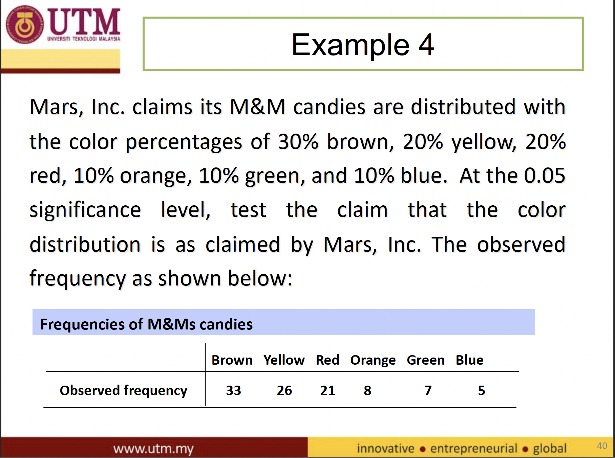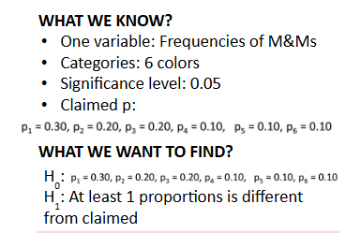

#Observed frequencies
mnm <- c(33, 26, 21, 8, 7, 5)

#Claimed probabilities (must sum to 1.0)
prob <- c(0.3, 0.2, 0.2, 0.1, 0.1, 0.1)

#Test against claimed probabilities
chisq_result <- chisq.test(mnm, p = prob, correct = FALSE)
x2 <- chisq_result$statistic

#critical value
alpha <- 0.05
x2.alpha <- qchisq(alpha,df=5,lower.tail=FALSE)

#get p-value of x2 of data
x2.pvalue <- pchisq(x2,df=5,lower.tail=FALSE)
#Note that R applies "Yates" correction by default; setting correct=FALSE is often preferred for standard tests.

3. Two-Way Contingency Table: Test of Independence (6 Minutes)
This test identifies whether two categorical variables (e.g., Gender and Crime Type) are independent of each other.
- File/Data Source: You can use a manual data frame or the built-in survey dataset from the MASS library.
- R Function: Use table() to group lists into a contingency table before running the test.

Exercise Snippet (Independence of Smoking and Exercise):

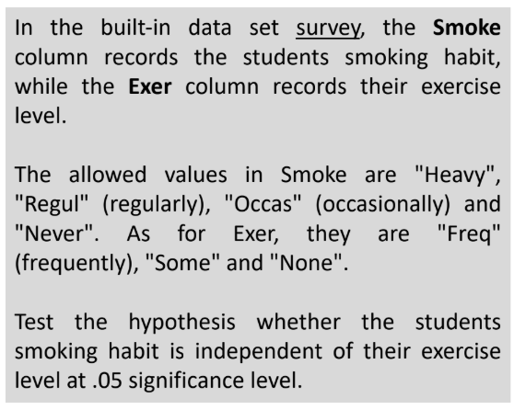
H₀: Smoking habit is independent of the exercise level
H₁: Smoking habit is not independent of the exercise level

#Load the MASS library for the built-in survey data
library(MASS)

#Create a contingency table for Smoking habit and Exercise level
tbl = table(survey$Smoke, survey$Exer)
tbl #View the table structure

#Perform the Chi-Square test
chisq_result <- chisq.test(tbl, correct=FALSE)

#critical value
alpha <- 0.05
x2.alpha <- qchisq(alpha,df=3,lower.tail=FALSE)

#get p-value of x2 of data
x2.pvalue <- pchisq(x2,df=3,lower.tail=FALSE)

*Troubleshooting: If you receive a warning about "incorrect approximation," it may be due to small cell values. In such cases, you can merge categories using cbind() to create a more robust table (e.g., merging "None" and "Some" exercise levels).

# create a new table
tbl2 = cbind(tbl[,'Freq'],tbl[,'None']+tbl[,'Some'])

# perform chi-square test on the data table
chisq.test(tbl2, correct=FALSE)

Corrected code:
#Load the MASS library for the built-in survey data
library(MASS)

#Create a contingency table for Smoking habit and Exercise level
tbl = table(survey$Smoke, survey$Exer)
tbl #View the table structure

#create a new table
tbl2 = cbind(tbl[,'Freq'],tbl[,'None']+tbl[,'Some'])

#perform chi-square test on the data table
chisq_result <- chisq.test(tbl2, correct=FALSE)
x2 <- chisq_result$statistic

#critical value
alpha <- 0.05
x2.alpha <- qchisq(alpha,df=6,lower.tail=FALSE)

#get p-value of x2 of data
x2.pvalue <- pchisq(x2,df=6,lower.tail=FALSE)

Quick Reference: Critical Values
To get the χ2 critical value for a specific alpha (e.g., 0.05) and degrees of freedom (df):
- qchisq(0.05, df=4, lower.tail=FALSE)
.

